Public Notice
REDUCTION IN MAXIMUM RETAIL PRICE (MRP) OF ANTI-CANCER MEDICINES
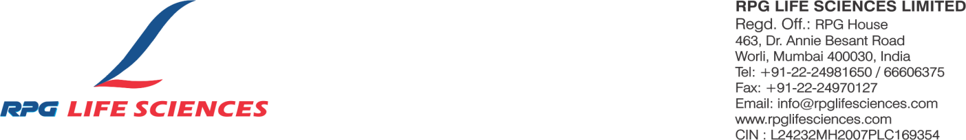

In compliance with Order S.O. 5690(E) dated 17th October 2026 issued by the National Pharmaceutical Pricing Authority (NPPA), Department of Pharmaceuticals, Government of India, under Paragraph 19 of the Drugs (Prices Control) Order, 2013, the trade margin on specified non-scheduled anti-cancer medicines has been capped at 30%.
Accordingly, RPG LIFE SCIENCES LTD. has reduced the MRP of the following products. The revised MRPs will be effective from 9th November 2026.
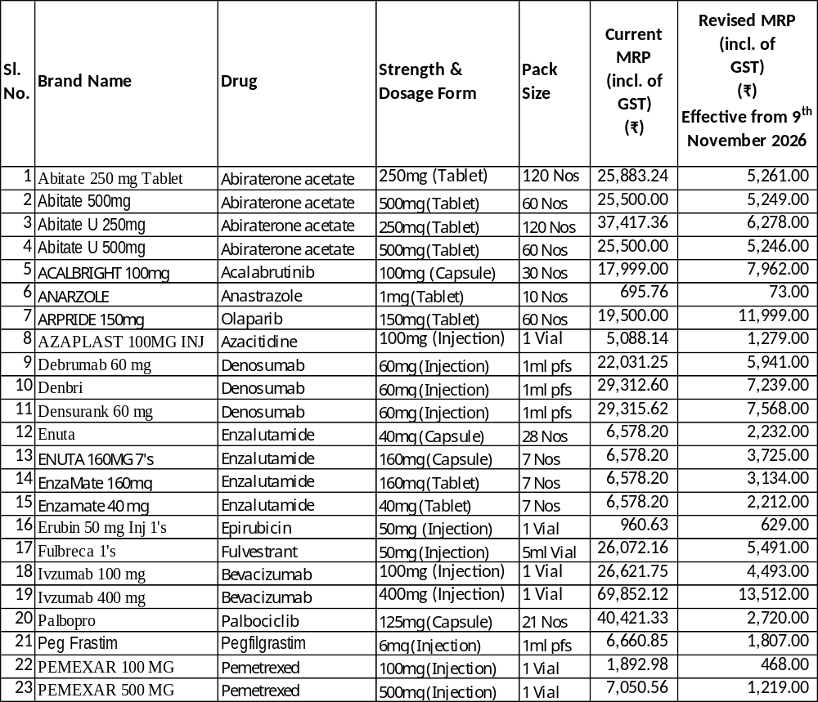

Ashok Nair
Managing Director, RPG Life Sciences Ltd.
Date: 24/10/2026
Place: Mumbai

